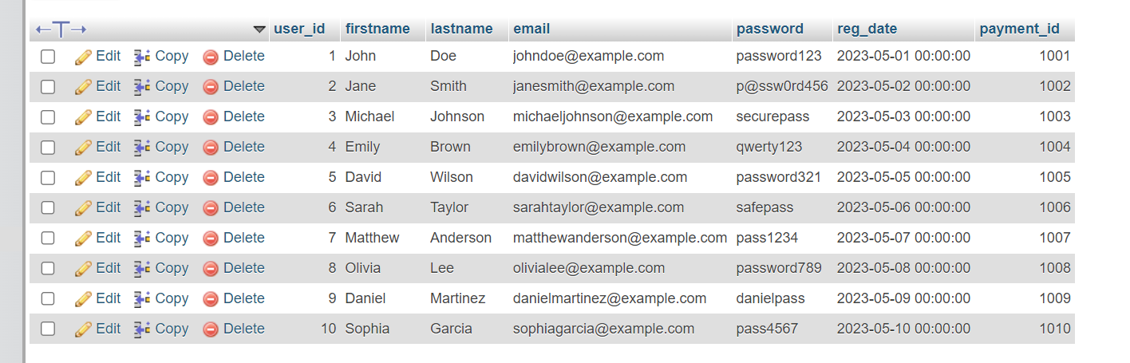
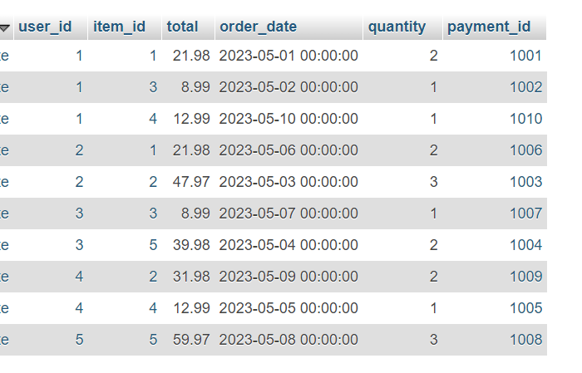
Week03 - Testing Database
SQL to check the tables
Q1. Check that each table will display the output presented in the individual tables
Code | Expected Output (Comment) | Actual Output (Screenshot)
Select *  From customer; | All records display (10 records) | 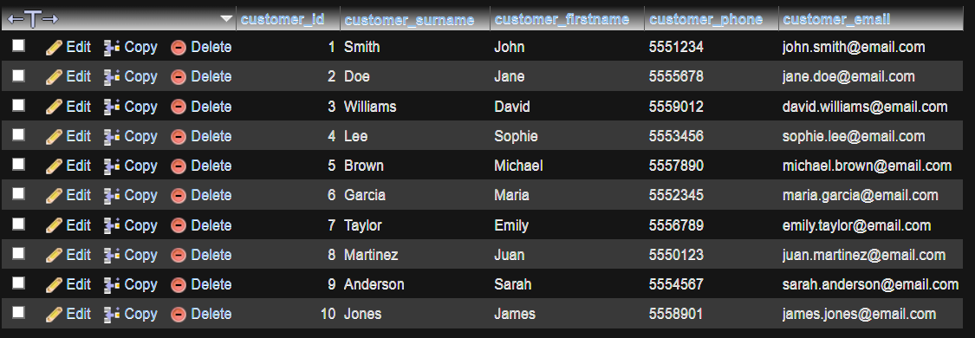
Select *  From ordering; |  | 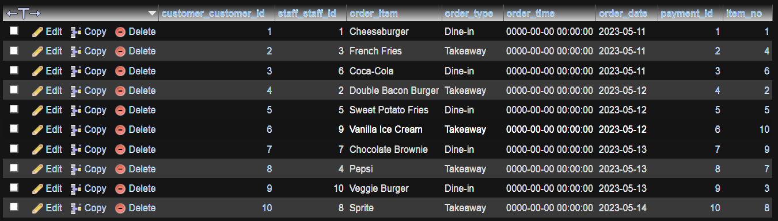

Q2. Show the output from two of the adjacent tables in turn – that is orders and item; users and item
Code | Expected Output (Comment) | Actual Output (Screenshot)
Select *  From customer  Join  order_item  Where  customer_id  = 1  ; |  | 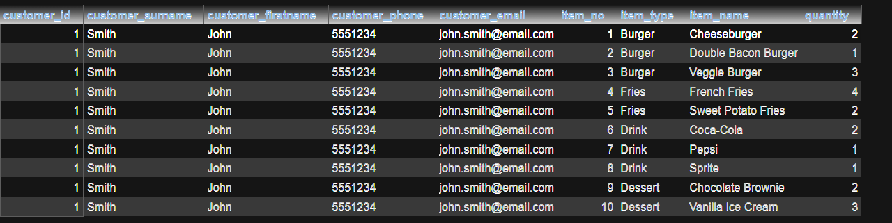
Select* from  ordering  join  order_item  WHERE  order_item.  item_no = 8  ; |  | 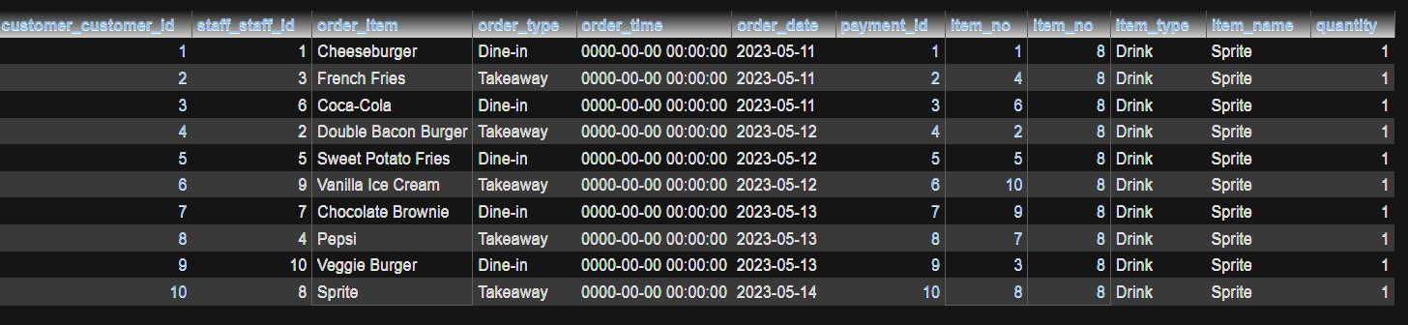

Q3. Connect all three tables and display the output that shows the output from these three tables – customer, ordering and item.
Code | Expected Output (Comment) | Actual Output (Screenshot)
Select * from  ordering  join  customer  where  item_no = 1; |  | 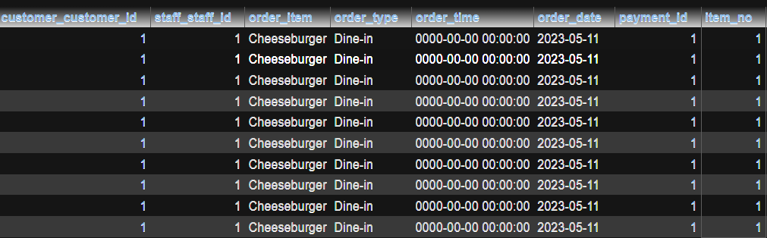  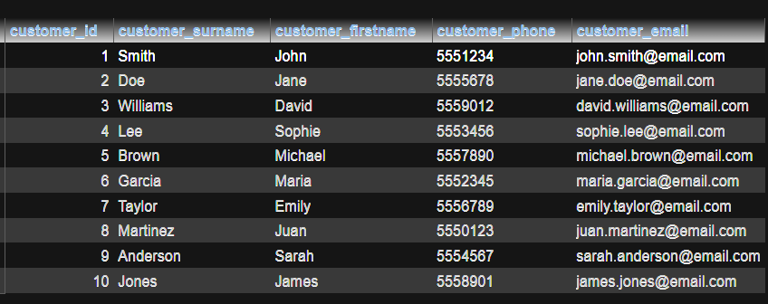
Select * from  customer  join  ordering  join  order_item  where order_item.  item_no = 5  and  customer_id  =1; |  | 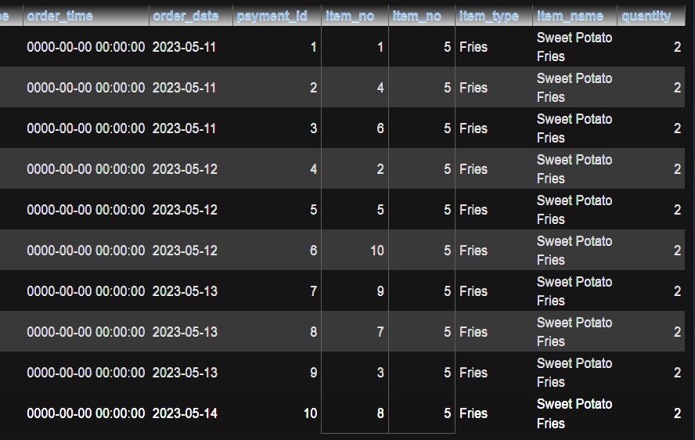  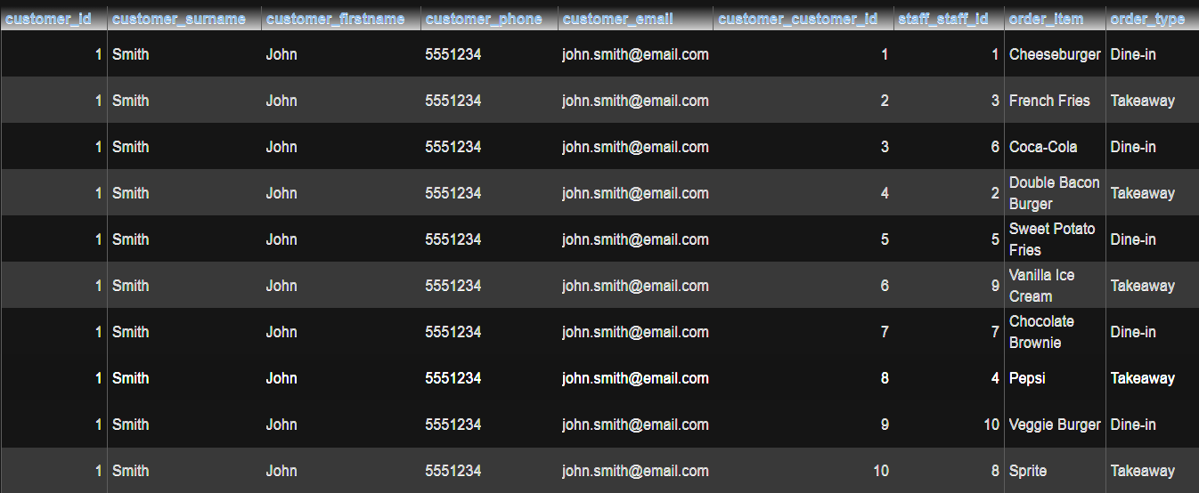

Q4. Create a query that will show the customer and items – so link these two
SELECT customer.customer_firstname, customer.customer_surname, ordering.order_item
FROM customer, ordering
WHERE customer.customer_id = ordering.customer_customer_id;
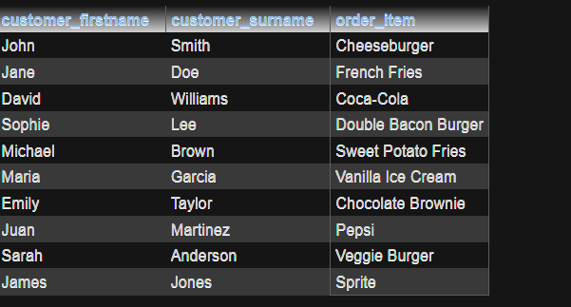

Q5. A manager wants to show a cataloguet of the items in the system – but only the following attributes showing: customer_id, customer_name, item_price
SELECT customer.customer_id, customer.customer_firstname, payment.payment_amount AS "Price"
FROM customer, ordering, payment
WHERE
((customer.customer_id = ordering.customer_customer_id))
AND
((ordering.payment_id = payment.payment_id);
